1. Creating and Renaming Files/Directories

Create a directory named test_dir using mkdir.

Inside test_dir, create an empty file called example.txt.

Rename example.txt to renamed_example.txt using mv

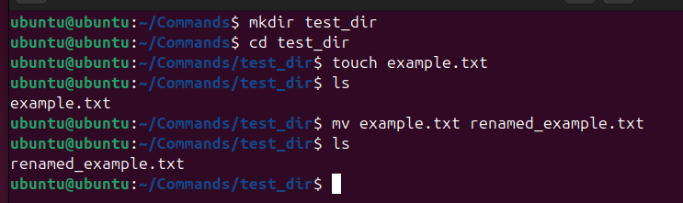

1. Viewing File Contents

Use cat to display the contents of /etc/passwd.

Display only the first 5 lines of /etc/passwd using head.

Display only the last 5 lines of /etc/passwd using tail.

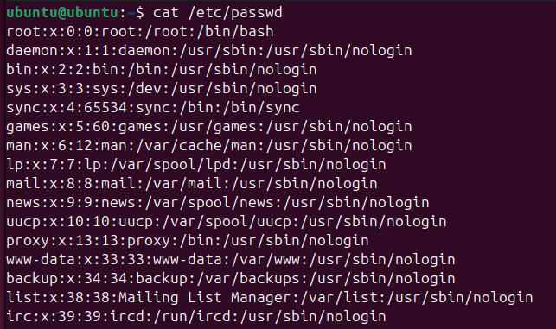

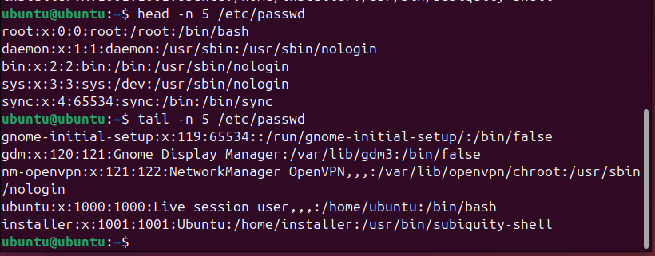

1. Searching for Patterns

Use grep to find all lines containing the word "root" in /etc/passwd.

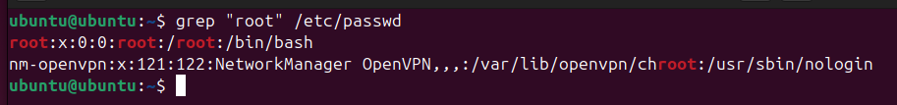

1. Zipping and Unzipping

Compress the test_dir directory into a file named test_dir.zip using zip.

Unzip test_dir.zip into a new directory named unzipped_dir.

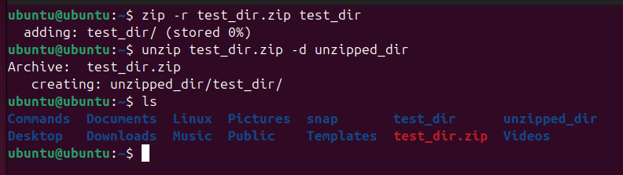

1. Downloading Files

Use wget to download a file from a URL (e.g., <https://example.com/sample.txt>).

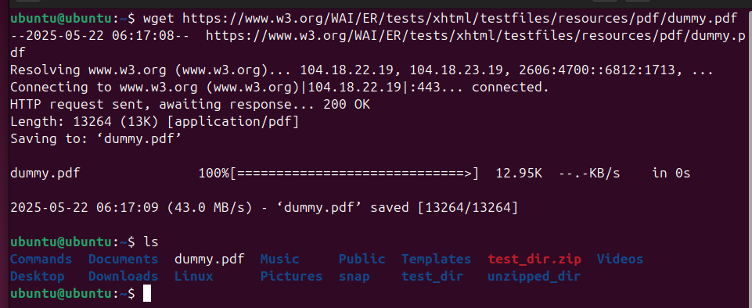

1. Changing Permissions

Create a file named secure.txt and change its permissions to read-only for everyone using chmod.

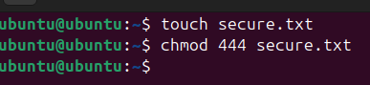

1. Working with Environment Variables

Use export to set a new environment variable called MY_VAR with the value "Hello, Linux!".

